CS300 PA0 Report
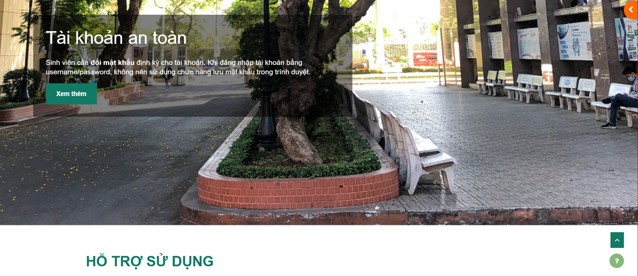

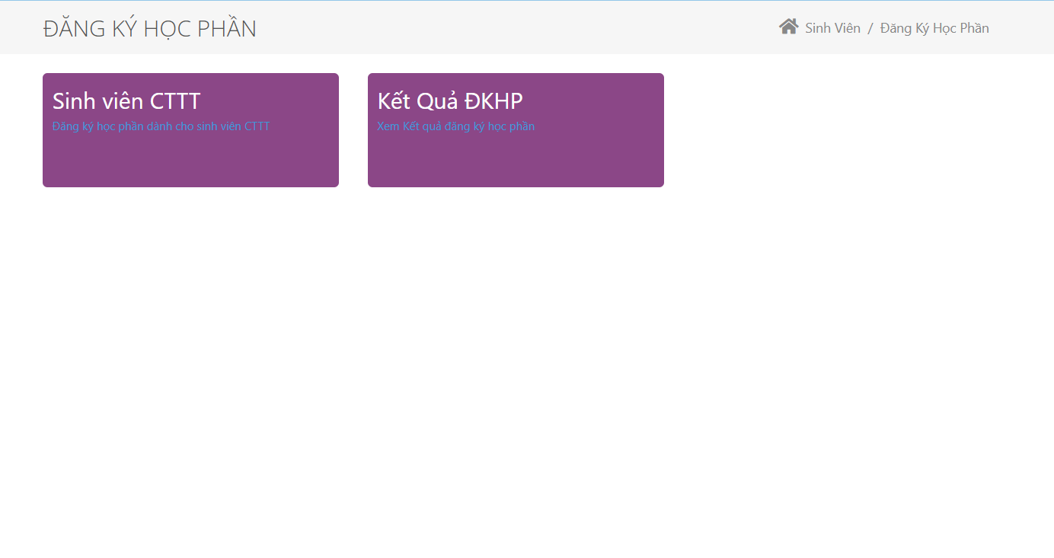

Group ID: 04
Group Name: HCMUS - YourName
Group member:
23125035 - Hoàng Đôn Thiện Hòa (Leader)
23125045 - Trần Nguyễn Đức Tâm
23125046 - Vũ Mai Thùy
23125070 - Nguyễn Công Viết Thành
23125071 - Nguyễn Đặng Hữu Thịnh


1. Introduction
Our project aims to simulate a Learning Management System (LMS) similar to Moodle (Moodle HCMUS), which is designed to provide a platform for organizing, creating, and managing courses and activities with a strong focus on collaborative learning.
Overall, our web application primarily targets an educational context, suitable for high school and university environments. Users can access the application via a web-based hyperlink connected to a secure server. In addition to the core features typically offered by Moodle, our system will incorporate enhanced functionalities derived from existing educational portals and integrate an AI-powered module (e.g., chatbot, Q&A assistant). These extensions aim to make the system more user-friendly, proactive, and efficient, particularly for both teachers and students.

2. Objectives
- To develop a functional LMS prototype simulating Moodle’s main operations.
- To implement essential course management features for both students and teachers.
- To integrate an AI assistant for interactive Q&A and course-related support.
- To ensure security, scalability, and usability in system design.
- To deploy the system with professional hosting (domain and VPS) for testing and demonstration purposes.

3. Overall plan
Project Duration: 10 weeks
Team Roles: Assigned per module in the detailed iteration plan.
Key Features:
- User Management: Profiles, calendars, and direct messaging.
- Application Preferences: User settings and AI chatbot integration.
- AI Feature: Integration of an LLM API (Gemini, GPT, etc.) for automated question-answering.
- Course Management: Course registration, removal, searching, and material organization for both teachers and students.
- User Preference:
- UI Customization: Dark mode/light mode, language settings, notification preferences,...
- Privacy Settings: Data sharing, profile visibility, and communication preferences,...

4. Materials
- Frontend: ReactJS x Vite (leveraging JSX for a dynamic and modular interface), HTML x CSS x JavaScript for supportive functions.
- Backend: Node.js for server-side logic and API handling.
- Database: PostgreSQL, with management options: local handling via Prisma, or cloud-based management via Supabase (Postgres platform with built-in authentication and instant APIs).
To enhance professionalism and usability, our team plans to acquire a custom domain to synchronize login features. This ensures secure account naming conventions, mitigating risks such as SQL injection or credential exploits. Additionally, a Virtual Private Server (VPS) may be rented to improve security, uptime, and administrative control.

5. Tools Setup:
For this project, we use the following tools:
- Moodle: Retrieving and submitting assignment
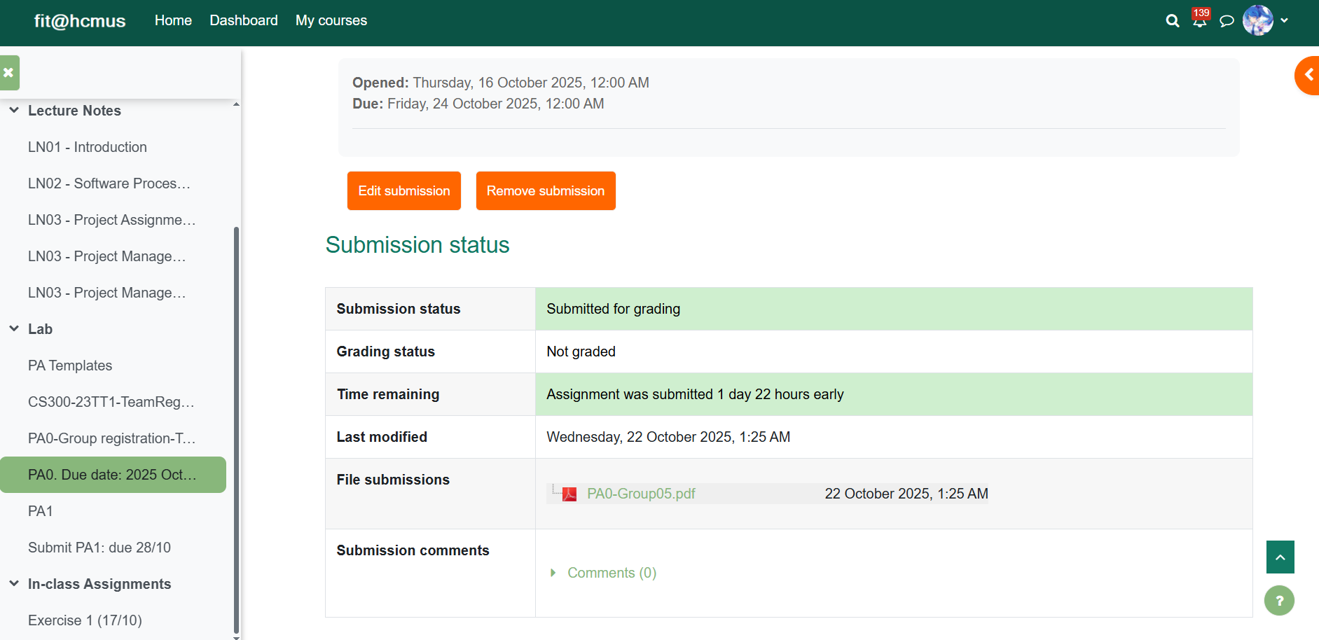
- Facebook group/Messenger: used for general notifications, class discussions, and questioning/answering. We also set up offline meeting schedule and record important notes from TA for the project.
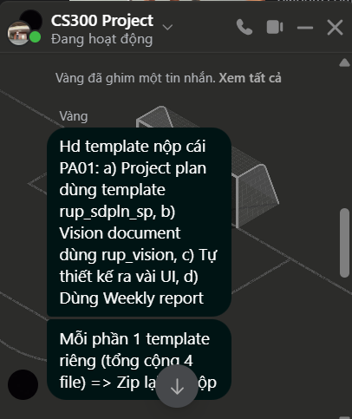
- Discord: Discussion and interaction within the team, share files, notify for important events, online meetings.
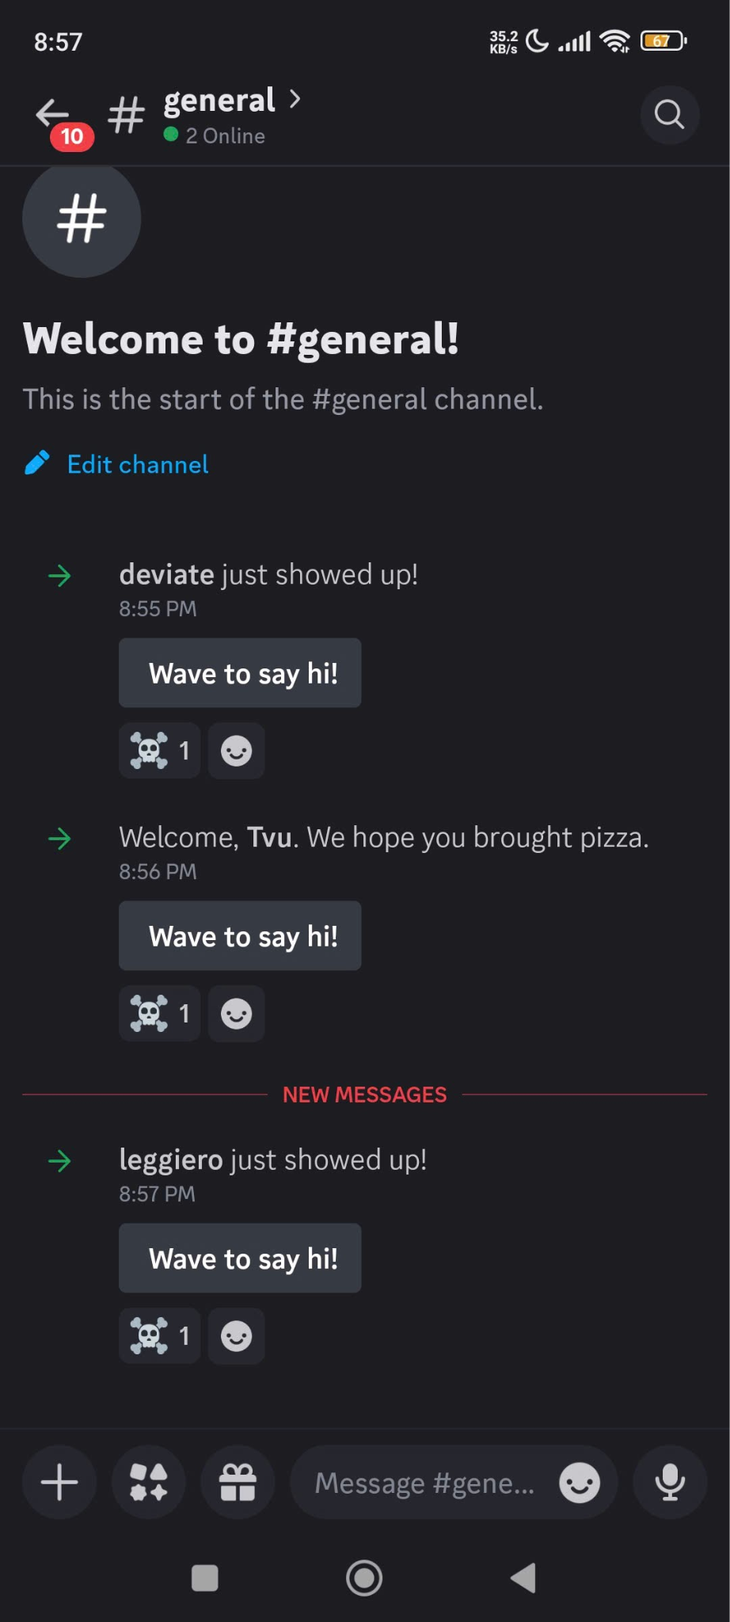
- Jira (Atlassian): scheduling, planning and assigning tasks for each member, controlling the project timeline and weekly reports.
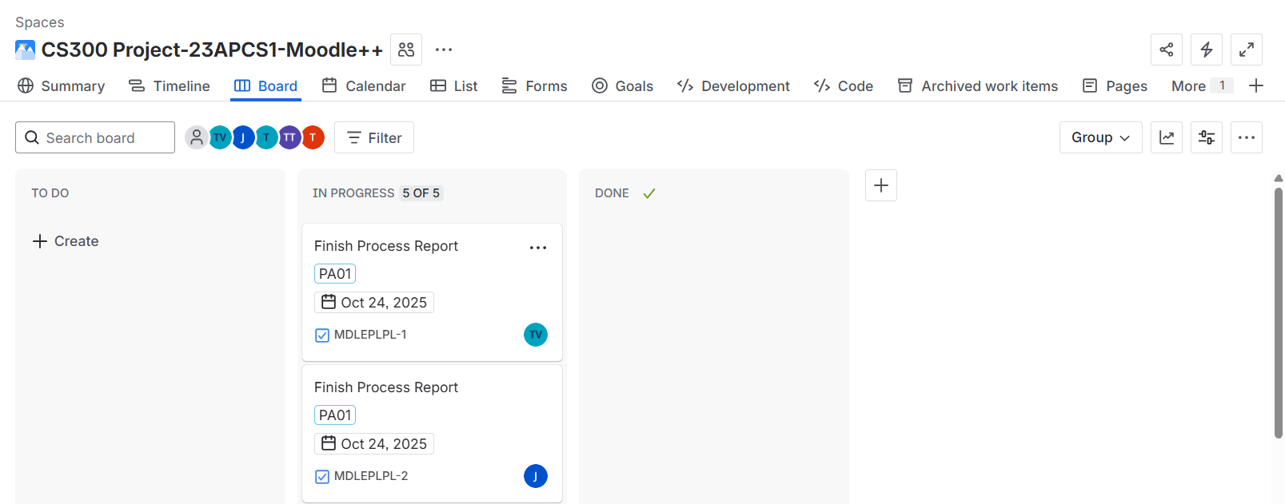
- Github: Storing source code and documentation. On the repository, each member will have their own branch for coding, updating or bug-fixing. After finishing one task and making sure that it runs properly, that person will announce to the group and merge with the main branch for the whole system, then testing one more time on the main branch to guarantee no bugs and fix conflicts (if any)
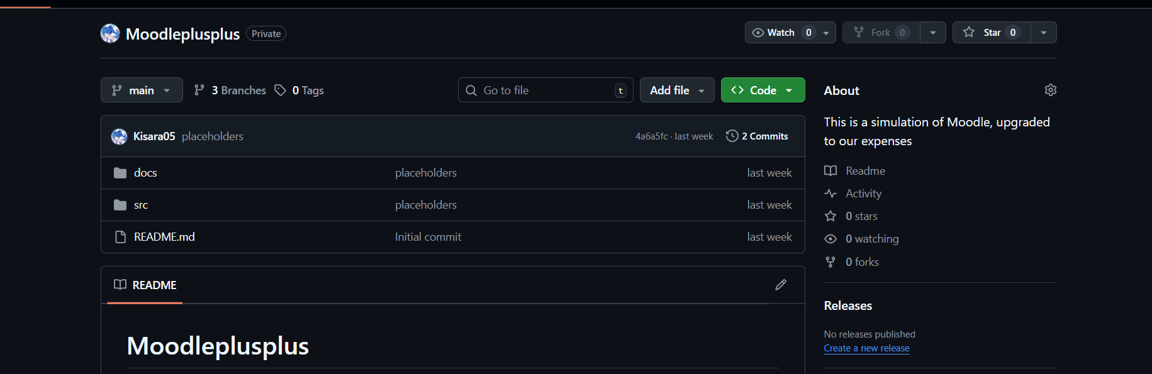

6. Detailed iteration plan
Phase | Duration | Activities | Participants
1. Environment Setup & Database Design | 1 week | Set up development environments; configure ReactJS (frontend), Node.js (backend), and Supabase (PostgreSQL) | All members
2. UI/UX Design | 1 week | Design interface using Figma; convert designs into JSX templates; establish initial routing structure | - BA & Dev: Vũ Mai Thùy  - Analyst & Designer: Nguyễn Đặng Hữu Thịnh  - Testing: Nguyễn Công Viết Thành
3. User Interaction Module | 2 weeks | Create user schema, connect database, develop login UI and authentication flow | - Frontend: Vũ Mai Thùy  - Backend + Testing: Hoàng Đôn Thiện Hòa
4. Course Management System | 2 weeks | Design and connect database schema for courses; implement logic for adding/removing members and materials; ensure data protection against SQL Injection, buffer overflow, etc. | - BA & Design: Hoàng Đôn Thiện Hòa  - Frontend: Vũ Mai Thùy  - Backend: Trần Nguyễn Đức Tâm  - Testing: Nguyễn Đặng Hữu Thịnh
5. Course Enrollment Module | 2 weeks | Implement enrollment logic and course status updates; develop UI components for enrollment workflow | - Developer: Nguyễn Công Viết Thành, Vũ Mai Thùy  - Testing: Nguyễn Công Viết Thành
6. AI Integration | 2 weeks | Fetch and integrate AI APIs (Gemini, GPT); fine-tune for context-aware responses and integrate within the platform’s interface | - Developer: Hoàng Đôn Thiện Hòa  - Tester: Trần Nguyễn Đức Tâm
Upon completion of all modules, a comprehensive testing phase will be initiated to ensure optimal functionality, eradicate defects, and enhance system security prior to deployment.

7. Outcomes
- A fully functional, web-based LMS simulation integrating AI-based support.
- Secure, scalable infrastructure using Node.js, ReactJS x Vite, and PostgreSQL.
- Improved learning experience through automation and interactivity.
- Demonstration-ready deployment on a registered domain with VPS hosting.

8. References
- https://www.geeksforgeeks.org/web-tech/web-technology/
- https://supabase.com/
- https://react.dev/
- https://nodejs.org/en
- https://ai.google.dev/gemini-api/docs/

